Scouts Game

Opening dua

Quick reminder

Topic - explanation

Split into groups of 4

4 stations:

* Sound buzzer – writing stuff back-to-back decoding each other
* Light practice -
* Sheet of morse code to translate

7

* Map/plane activity

Teach them morse code, where it originated from and setting up/using the device:

* Made by Samuel F.B. Morse in 1830
* During WW2 it was used to send important messages
* Make them spell their names using morse code

The actual game:

Split them into 4 teams so that there are 2 teams for one group. In the groups they will be opposite each other – make sure that there are chairs or something to separate the groups.

They will create paper aeroplane which must contain their message (in morse code). However, if their paper aeroplane does not make it to the other side, they can either make another paper aeroplane but they are limited to the number of papers they have (3 – so they can either make the aeroplanes smaller by using smaller amounts of the paper) or use the morse code machine which they

HELP MY NAME IS GEORGE I AM STUCK ON AN ISLAND THERE ARE PEOPLE WHO ARE GOING TO EAT ME HELPI HAVE BEEN STUCK FOR THE PAST 3 DAYS AND CANNOT FIND ANY HELP ON THE ISLANDI HAVE A FRIEND NAMED BILLY WHO CAN HELP USHELP BUT YOU HAVE TO CALL HIS NUMBER WHICH IS 023827823ALSO I HAVE A FRIEND NAMED UMAIR HE GOES TO HARROW SCOUTS IF YOU SEE HIM MAKE SURE TO TELL HIM THAT I AM STUCK ON AN ISLAND

ASSALAMUALAYKUM MY NAME IS YUSUF AND I GO TO HARROW SCOUTS DO YOU WANT TO KNOW A SECRET ABOUT HARROW SCOUTS IN HARROW SCOUTS THERE IS A SECRET ROOM IN THE CORNER OF THE HALL WHICH HAS A SIGNED SHIRT FROM RONALDO RONALDO IS THE GOAT UNLIKE MESSI WHO IS VERY BAD AT FOOTBALL I HATE MESSI I MET RONALDO WHEN I WENT TO SAUDI ARABIA AND I SAW HIM IN AL NASR MAKE SURE TO SHOUT SUI IF YOU ARE READING THIS

DEAR PERSON I HOPE THIS LETTER FINDS YOU WELL. I WANTED TO SHARE WITH YOU SOME EXCITING NEWS. OUR SCOUT TROOP IS PLANNING A HIKE NEXT WEEK WE WILL BE EXPLORING THE GREAT OUTDOORS, LEARNING NEW SKILLS, AND HAVING LOTS OF FUN.PLEASE LET ME KNOW IF YOU CAN JOIN US. IT WOULD BE WONDERFUL TO HAVE YOU THERE. LOOKING FORWARD TO SEEING YO

/ = SPACE

.... . .-.. .--. / -- -.-- / -. .- -- . / .. ... / --. . --- .-. --. . / .. / .- -- / ... - ..- -.-. -.- / --- -. / .- -. / .. ... .-.. .- -. -.. / - .... . .-. . / .- .-. . / .--. . --- .--. .-.. . / .-- .... --- / .- .-. . / --. --- .. -. --. / - --- / . .- - / -- . / .... . .-.. .--.

.. / .... .- ...- . / -... . . -. / ... - ..- -.-. -.- / ..-. --- .-. / - .... . / .--. .- ... - / ...-- / -.. .- -.-- ... / .- -. -.. / -.-. .- -. -. --- - / ..-. .. -. -.. / .- -. -.-- / .... . .-.. .--. / --- -. / - .... . / .. ... .-.. .- -. -..

.. / .... .- ...- . / .- / ..-. .-. .. . -. -.. / -. .- -- . -.. / -... .. .-.. .-.. -.-- / .-- .... --- / -.-. .- -. / .... . .-.. .--. / ..- ...

.... . .-.. .--. / -... ..- - / -.-- --- ..- / .... .- ...- . / - --- / -.-. .- .-.. .-.. / .... .. ... / -. ..- -- -... . .-. / .-- .... .. -.-. .... / .. ... / ----- ..--- ...-- ---.. ..--- --... ---.. ..--- ...--

.- .-.. ... --- / .. / .... .- ...- . / .- / ..-. .-. .. . -. -.. / -. .- -- . -.. / ..- -- .- .. .-. / .... . / --. --- . ... / - --- / .... .- .-. .-. --- .-- / ... -.-. --- ..- - ... / .. ..-. / -.-- --- ..- / ... . . / .... .. -- / -- .- -.- . / ... ..- .-. . / - --- / - . .-.. .-.. / .... .. -- / - .... .- - / .. / .- -- / ... - ..- -.-. -.- / --- -. / .- -. / .. ... .-.. .- -. -..

/ = SPACE

.- ... ... .- .-.. .- -- ..- .- .-.. .- -.-- -.- ..- -- / -- -.-- / -. .- -- . / .. ... / -.-- ..- ... ..- ..-. / .- -. -.. / .. / --. --- / - --- / .... .- .-. .-. --- .-- / ... -.-. --- ..- - ... / -.. --- / -.-- --- ..- / .-- .- -. - / - --- / -.- -. --- .-- / .- / ... . -.-. .-. . - / .- -... --- ..- - / .... .- .-. .-. --- .-- / ... -.-. --- ..- - ... / .. -. / .... .- .-. .-. --- .-- / ... -.-. --- ..- - ... / - .... . .-. . / .. ... / .- / ... . -.-. .-. . - / .-. --- --- -- / .. -. / - .... . / -.-. --- .-. -. . .-. / --- ..-. / - .... . / .... .- .-.. .-.. / .-- .... .. -.-. .... / .... .- ... / .- / ... .. --. -. . -.. / ... .... .. .-. - / ..-. .-. --- -- / .-. --- -. .- .-.. -.. ---

.-. --- -. .- .-.. -.. --- / .. ... / - .... . / --. --- .- - / ..- -. .-.. .. -.- . / -- . ... ... .. / .-- .... --- / .. ... / ...- . .-. -.-- / -... .- -.. / .- - / ..-. --- --- - -... .- .-.. .-.. / .. / .... .- - . / -- . ... ... ..

.. / -- . - / .-. --- -. .- .-.. -.. --- / .-- .... . -. / .. / .-- . -. - / - --- / ... .- ..- -.. .. / .- .-. .- -... .. .- / .- -. -.. / .. / ... .- .-- / .... .. -- / .. -. / .- .-.. / -. .- ... .-.

-- .- -.- . / ... ..- .-. . / - --- / ... .... --- ..- - / ... ..- .. / .. ..-. / -.-- --- ..- / .- .-. . / .-. . .- -.. .. -. --. / - .... .. ...

/ = SPACE (HARD ACTIVITY)

-.. . .- .-. / .--. . .-. ... --- -.

.. / .... --- .--. . / - .... .. ... / .-.. . - - . .-. / ..-. .. -. -.. ... / -.-- --- ..- / .-- . .-.. .-.. / .. / .-- .- -. - . -.. / - --- / ... .... .- .-. . / .-- .. - .... / -.-- --- ..- / ... --- -- . / . -..- -.-. .. - .. -. --. / -. . .-- ... / --- ..- .-. / ... -.-. --- ..- - / - .-. --- --- .--. / .. ... / .--. .-.. .- -. -. .. -. --. / .- / .... .. -.- . / -. . -..- - / .-- . . -.-

.-- . / .-- .. .-.. .-.. / -... . / . -..- .--. .-.. --- .-. .. -. --. / - .... . / --. .-. . .- - / --- ..- - -.. --- --- .-. ... / .-.. . .- .-. -. .. -. --. / -. . .-- / ... -.- .. .-.. .-.. ... / .- -. -.. / .... .- ...- .. -. --. / .-.. --- - ... / --- ..-. / ..-. ..- -.

.--. .-.. . .- ... . / .-.. . - / -- . / -.- -. --- .-- / .. ..-. / -.-- --- ..- / -.-. .- -. / .--- --- .. -. / ..- ... / .. - / .-- --- ..- .-.. -.. / -... . / .-- --- -. -.. . .-. ..-. ..- .-.. / - --- / .... .- ...- . / -.-- --- ..- / - .... . .-. . / .-.. --- --- -.- .. -. --. / ..-. --- .-. .-- .- .-. -.. / - --- / ... . . .. -. --. / -.-- --- ..-

Group 1:

You are stranded on an island; you have water but no food and one of your people on your team is allergic to nuts. Your team may be able to survive for 5 days but will need supplies: Toilet paper and toothpaste. You also find out that there are some savages in the island that are looking for food and they may want to eat you. You and your team are located on the Northeast of the island in the grid reference: ______ where you have put up tents. You have 3 pieces of paper and a morse code machine to help you send details of what you need. You must tell them of your location and what you need.

**USE COMPASS BEARINGS, GRID REFERENCES TO HELP THEM**

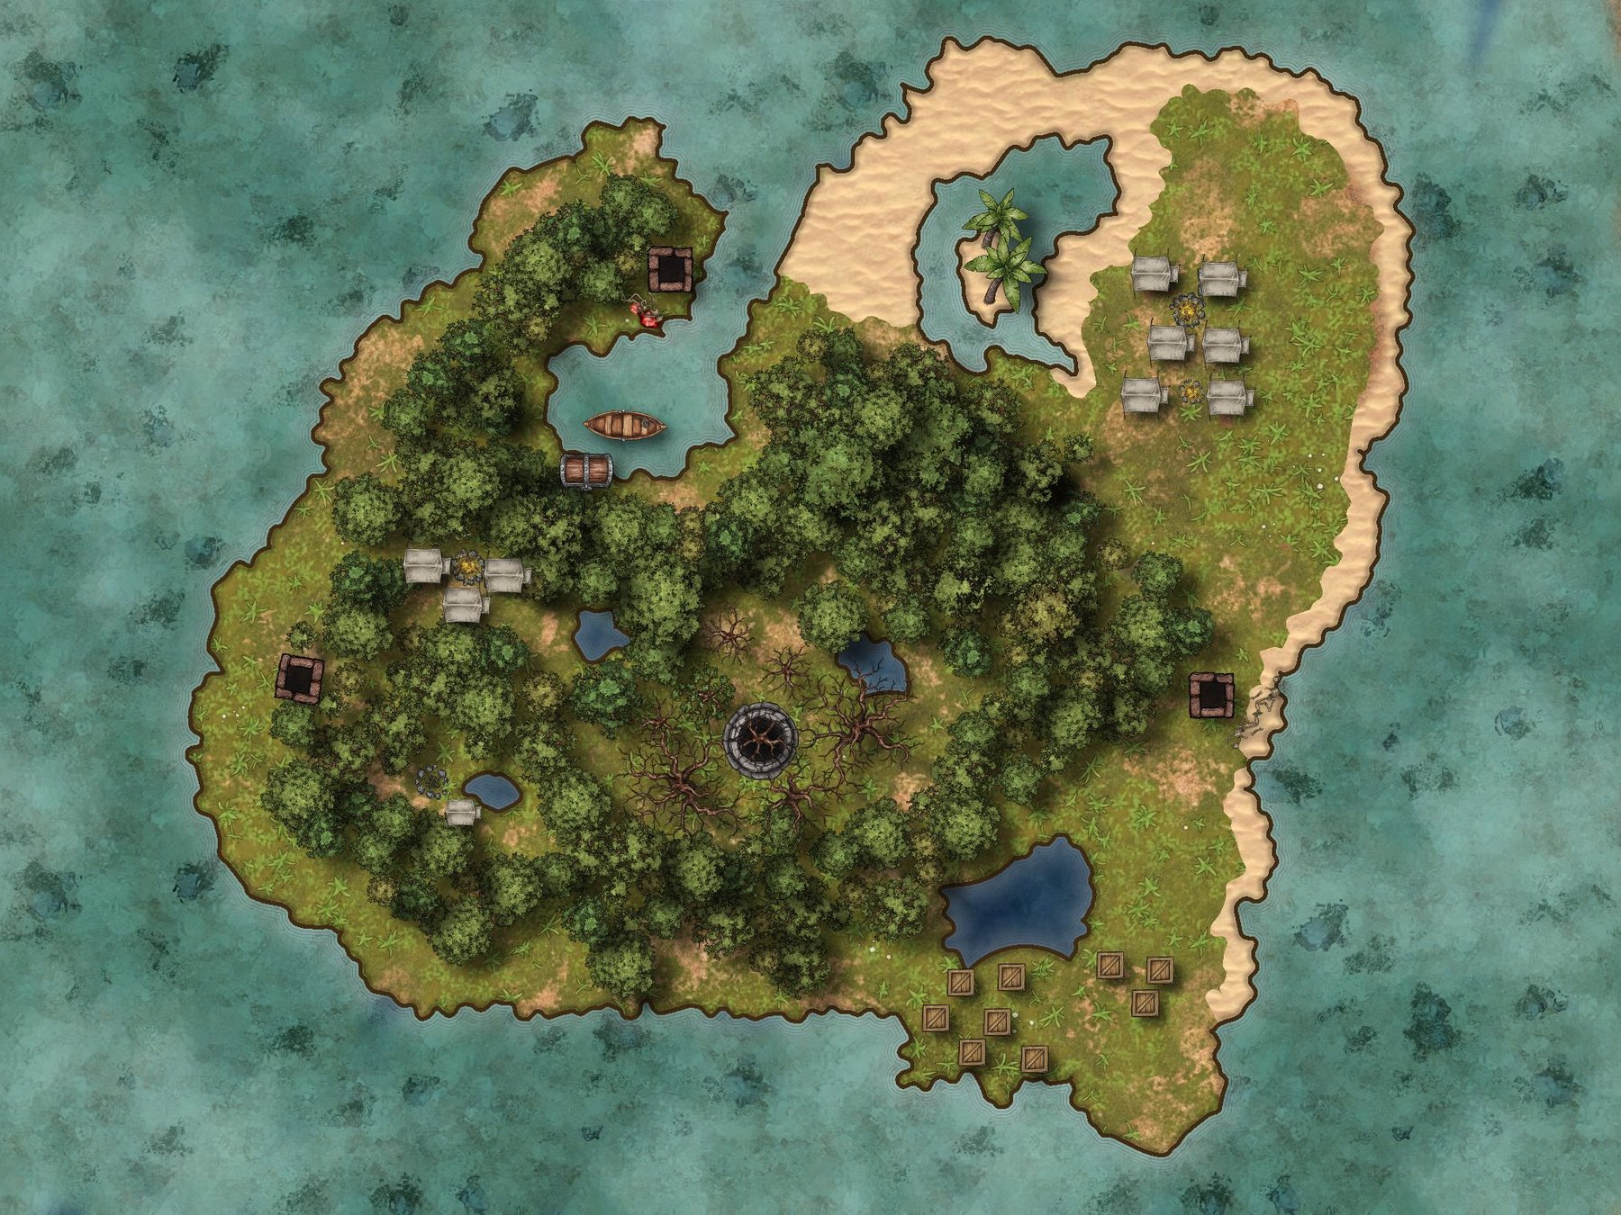

Group 2:





Your friends are stranded on an island, you do not know where they are however you have a map of the island and can see signals from them. The part in red is the only place you can send supplies in to help your friends, **USE COMPASS BEARINGS AND A DESCRIPTION OF THE LOCATION AND GRID REFERENCES TO HELP THEM**. Your friends will send out details of what they need and where they are in morse code. Watch carefully with what they send you and make sure you send them back in morse code what they need.

“,” (comma) = --..-- 